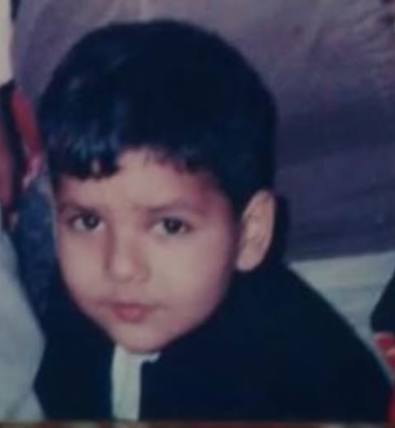
Why, "belihaazi"?

To be in a system where power, and knowledge both flow top down- the ability, desire, and action - of asking a question, challenging the "obvious" and not doing things just because they've been "approved" of as the correct way of doing something -

It puts you in a spot.

Call it my disability, but I've never been able to take things at face value. The expression "but why" felt more like a suffix to me.

Just as is the case with every 5 year old.

Just as is appreciated in every 10 year old.

Just as annoying it gets in every 14 year old.

And just as criminal it feels after you're 18.

Most people who perceive themselves to be "authority" , also understand "why?" As a question to their authority.

Our brains have the incredible capacity to mistake one thing for another.

Confuse care for love.

A joke as a personal attack.

Articulation for intelligence.

Beratement as humour.

Bullying for play.

Questions - for disrespect.

An on, and on.

Eventually, it boils down to if you're going to do what you wanted to do anyway - or accommodate for the other perspectives and take a pause.

When it came to questions - the answer was clear for me. I wanted to keep seeing the world like I was 5. I wanted to chase the curiosities it had to offer.

I had to bear the cost of asking a question.

The cost of being seen as someone disrespectful.

Jise kisi baat ka "lihaaz" na ho.

And that's what I've always done- learnt, wrote, sang and worked- out of belihaazi.

I'd often think it is a "phase" - an "outlet" - or in the lowest form- a trash can where I keep dumping my thoughts , one that I cannot afford to have on my mind all the time.

My perspective was my language, and my thoughts my currency.

And "Understanding" - the only commodity that mattered.

But belihaazi has been quiet lately.

Mostly, because he succeeded in helping utkarsh have a career that allowed him to do everything he was doing through this alter ego.

There's a flip side to it though.

Anything in our lives is only as good as the amount of meaning we find in it. Take that away- and the thing is as good as dead.

I don't find meaning in being understood anymore.

Only understanding.

